Star-Cupola
# Source: AI Source: Provided by: [Data Path: Persons Table -> ID Column: 1, Name_En Column: Motasem Essam] -> From: [ChatGPT] on [7/25/2026]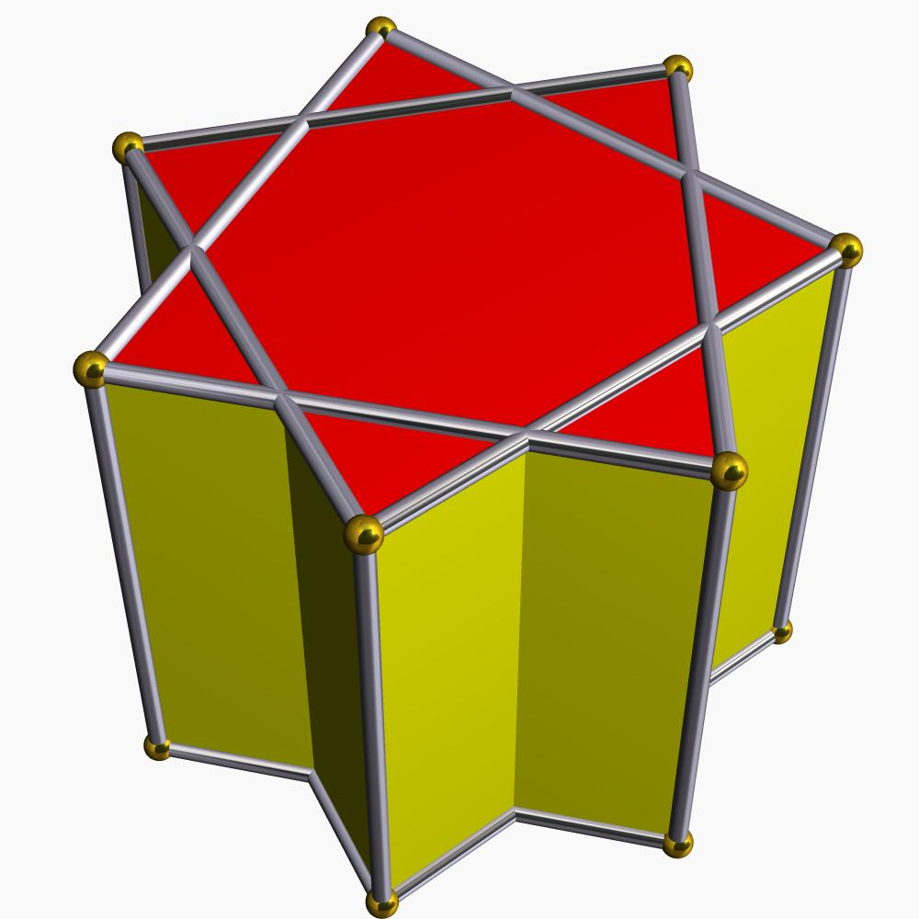

Definition
# Source: AI Source: Provided by: [Data Path: Persons Table -> ID Column: 1, Name_En Column: Motasem Essam] -> From: [ChatGPT] on [7/25/2026]
A Star-cupola is a non-convex, star-shaped variation of a cupola. It is constructed using a regular star polygon as one of its bases, with a larger corresponding star polygon forming the opposite base.
Like an ordinary cupola, its lateral surface is formed by an alternating arrangement of triangular and square faces. However, the star-shaped base introduces intersecting edges and a non-convex overall structure.
Star-cupola are represented using star-polygon notation such as $\{n/d\}$, where:
- $n$ = number of vertices of the star polygon.
- $d$ = step size connecting the vertices.
- $\{n/d\}$ = the corresponding star polygon.
The other base is represented by $\{2n/d\}$.

Geometric Structure
# Source: AI Source: Provided by: [Data Path: Persons Table -> ID Column: 1, Name_En Column: Motasem Essam] -> From: [ChatGPT] on [7/25/2026]
A Star-cupola generally consists of:
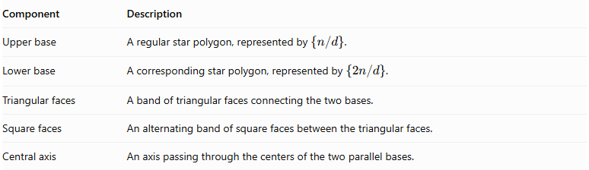
Component | Description
Upper base | A regular star polygon, represented by $\{n/d\}$.
Lower base | A corresponding star polygon, represented by $\{2n/d\}$.
Triangular faces | A band of triangular faces connecting the two bases.
Square faces | An alternating band of square faces between the triangular faces.
Central axis | An axis passing through the centers of the two parallel bases.

Types of Star-Cupola
# Source: AI Source: Provided by: [Data Path: Persons Table -> ID Column: 1, Name_En Column: Motasem Essam] -> From: [ChatGPT] on [7/25/2026]
Examples of the Star-cupola family include:
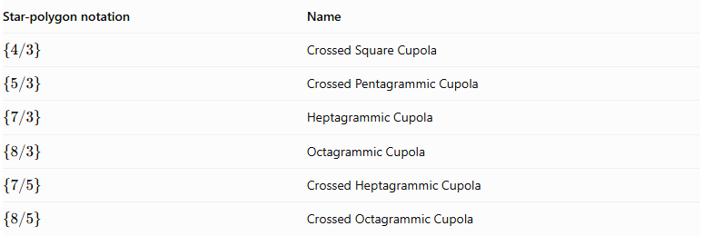
Star-polygon notation | Name
$$\{4/3\}$$ | Crossed Square Cupola
$$\{5/3\}$$ | Crossed Pentagrammic Cupola
$$\{7/3\}$$ | Heptagrammic Cupola
$$\{8/3\}$$ | Octagrammic Cupola
$$\{7/5\}$$ | Crossed Heptagrammic Cupola
$$\{8/5\}$$ | Crossed Octagrammic Cupola
These are examples from the documented star-cupola family, not an exhaustive list of every possible construction. <Cite refs={["turn302944search12","turn302944search10"]}/>

Mathematical Properties
# Source: AI Source: Provided by: [Data Path: Persons Table -> ID Column: 1, Name_En Column: Motasem Essam] -> From: [ChatGPT] on [7/25/2026]
Star-cupola have some important construction conditions:
- The upper star polygon is represented by $\{n/d\}$.
- The corresponding lower base is represented by $\{2n/d\}$.
- The star-cupola construction is possible under the condition:
$$\frac{6}{5}<\frac{n}{d}<6$$
where $d$ is odd.
- At the limiting values, the cupola collapses into a plane figure.
- If $d$ is even, the lower base becomes degenerate; a related construction called a star-cuploid can be formed instead. <Cite refs={["turn302944search12","turn302944search6"]}/>

Geometric Characteristics
# Source: AI Source: Provided by: [Data Path: Persons Table -> ID Column: 1, Name_En Column: Motasem Essam] -> From: [ChatGPT] on [7/25/2026]
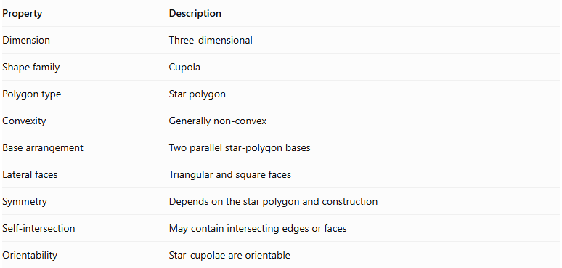
Property | Description
Dimension | Three-dimensional
Shape family | Cupola
Polygon type | Star polygon
Convexity | Generally non-convex
Base arrangement | Two parallel star-polygon bases
Lateral faces | Triangular and square faces
Symmetry | Depends on the star polygon and construction
Self-intersection | May contain intersecting edges or faces
Orientability | Star-cupola are orientable

Constructing Star-Cupola in Solid Geometry

Geometric Instruments Used
# Source: AI Source: Provided by: [Data Path: Persons Table -> ID Column: 1, Name_En Column: Motasem Essam] -> From: [ChatGPT] on [7/25/2026]
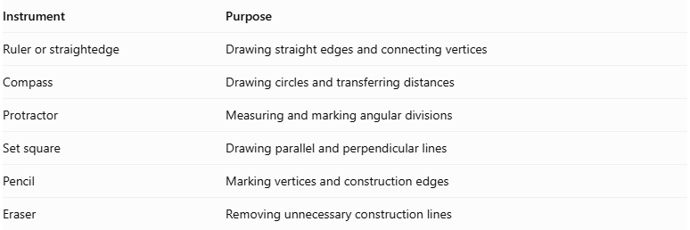
Instrument | Purpose
Ruler or straightedge | Drawing straight edges and connecting vertices
Compass | Drawing circles and transferring distances
Protractor | Measuring and marking angular divisions
Set square | Drawing parallel and perpendicular lines
Pencil | Marking vertices and construction edges
Eraser | Removing unnecessary construction lines
Construction method: Instrument-based geometric construction using geometric instruments, angular measurements, and geometric relationships. It does not use coordinate-based construction.

Instrument-Based Construction Procedures

Selecting the Star-Cupola Type
# Source: AI Source: Provided by: [Data Path: Persons Table -> ID Column: 1, Name_En Column: Motasem Essam] -> From: [ChatGPT] on [7/25/2026]
- Select the intended star-cupola type.
- Identify the upper and lower star-polygon bases.
- Determine their Schläfli symbols.
- Identify the number of vertices and the required connection pattern for each base.
- Determine the lateral-face arrangement.

Constructing the Upper Star Polygon
# Source: AI Source: Provided by: [Data Path: Persons Table -> ID Column: 1, Name_En Column: Motasem Essam] -> From: [ChatGPT] on [7/25/2026]
- Draw a circle using a compass.
- Mark equally spaced points around its circumference.
- Number the vertices consecutively.
- Connect the vertices according to the selected star-polygon step.
- Complete the upper star polygon.
For a star polygon $\{n/k\}$, connect each vertex to the vertex $k$ positions ahead, wrapping around the numbering when necessary.

Constructing the Lower Star Polygon
# Source: AI Source: Provided by: [Data Path: Persons Table -> ID Column: 1, Name_En Column: Motasem Essam] -> From: [ChatGPT] on [7/25/2026]
- Draw a second circle for the lower base.
- Mark the required number of equally spaced vertices.
- Number the vertices consecutively.
- Connect the vertices according to the lower base's star-polygon notation.
- Complete the lower star polygon.

Positioning the Bases
# Source: AI Source: Provided by: [Data Path: Persons Table -> ID Column: 1, Name_En Column: Motasem Essam] -> From: [ChatGPT] on [7/25/2026]
- Represent the two bases as parallel planes.
- Position the upper base above the lower base.
- Align their orientations according to the selected cupola arrangement.
- Maintain the intended rotational symmetry.
- Ensure that the base vertex positions are compatible with the lateral-face connections.

Constructing the Lateral Faces
# Source: AI Source: Provided by: [Data Path: Persons Table -> ID Column: 1, Name_En Column: Motasem Essam] -> From: [ChatGPT] on [7/25/2026]
- Identify the corresponding vertices and edges of the two bases.
- Connect the bases according to the selected star-cupola face-adjacency pattern.
- Construct the triangular lateral faces.
- Construct the square or other specified quadrilateral lateral faces.
- Check that the lateral structure closes correctly.
- Preserve the intended star-shaped arrangement and intersections.

Completing the Three-Dimensional Representation
# Source: AI Source: Provided by: [Data Path: Persons Table -> ID Column: 1, Name_En Column: Motasem Essam] -> From: [ChatGPT] on [7/25/2026]
- Darken the visible edges.
- Use dashed lines for hidden edges where appropriate.
- Distinguish the upper and lower star-polygon bases.
- Check the rotational symmetry.
- Verify that the resulting model represents the selected star-cupola type.
Construction accuracy note: Exact construction depends on the selected polygon. Some regular polygons can be constructed with only a compass and unmarked straightedge, while others require additional measured-angle instruments or approximate construction. A protractor can be used to mark angular divisions. These are instrument-based geometric procedures, not coordinate-based construction.

Distinction Between Star-cupola and Star-cuploids
# Source: AI Source: Provided by: [Data Path: Persons Table -> ID Column: 1, Name_En Column: Motasem Essam] -> From: [ChatGPT] on [7/25/2026]
- Star-cupola: Retains both star-polygon bases.
- Star-cuploid: A related construction in which the degenerate lower base is withdrawn and the lateral faces connect to one another instead.
They are related geometrical constructions, but they are not interchangeable terms.

Main Classification
# Source: AI Source: Provided by: [Data Path: Persons Table -> ID Column: 1, Name_En Column: Motasem Essam] -> From: [ChatGPT] on [7/25/2026]
Solid Geometry
└── Types of Solids
└── Cupola
└── Star-cupolae
├── Crossed Square Cupola
├── Crossed Pentagrammic Cupola
├── Heptagrammic Cupola
├── Octagrammic Cupola
├── Crossed Heptagrammic Cupola
└── Crossed Octagrammic Cupola

Conclusion
# Source: AI Source: Provided by: [Data Path: Persons Table -> ID Column: 1, Name_En Column: Motasem Essam] -> From: [ChatGPT] on [7/25/2026]
Star-cupola are non-convex cupola constructions characterized by star-polygon bases and alternating triangular and square lateral faces. They extend the ordinary cupola concept into star-shaped polyhedral geometry.

